Tracking Back Study - Quantitative data
Contents
Section A: Degree courses, stage of study, gender and type of schools attended etc 1
Course being studied 1
University grade distribution of respondents 1
Breakdown of respondents by phase of study and year group 2
When was the course chosen? 3
Type of schools attended 4
Gender 6
Students reporting disability 7
Ethnic Background 8
Profiles by grade, gender and school 9
Section B: Examinations taken 10
Further mathematics opportunities which were available 11
STEP opportunities which were available 11
STEP and FM support 12
Section C: Influences and preparedness for university course 12
Influences of key factors on choice of type of course 12
Usefulness of key factors in preparation for university course 14
Influences in decision to study university course 15
Do multiple influences/useful interventions boost grade? 15
What schools do well prepared respondents come from? 15
Useful preparations for university course 16
Would any additional support or intervention have helped in hindsight? 19
Section D: Concerning teaching received 20
Influential or inspiring teachers 20
Memorable mathematics teachers 21
Effects of 'good' mathematics teaching 22
Acceleration 23
Additional mathematics support outside of lessons 24
Amount of mathematics learned 25
Amount of support received at school and university 26
Section E: Perceptions of Mathematics 27
Views of mathematics 27
Importance of mathematics 28
Interest in mathematics 28
Enjoyment of mathematics 29
Understanding of mathematics 29
Section F: Doing Mathematics 30
Ways of learning 30
Difficulties in doing mathematics 32
Difficulties encountered when working on mathematics. 33
Important aspects of mathematics questions 35
Important features of a maths question 35
Self-views of mathematical ability 37
Difficulty of mathematics 37
Section G: NRICH and Ask NRICH 38
Proportions of respondents who know they have used NRICH 38
Section H: Overall 38
Key influences 39
Key moments 41
Appreciation of mathematics in hindsight 43

Section A: Degree courses, stage of study, gender and type of schools attended etc

Course being studied

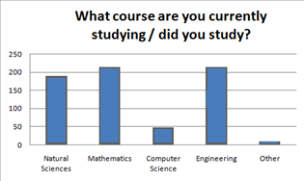

University grade distribution of respondents
We were able to determine 447 part IA grades, 230 part IB and 80 part II grades for the respondents. In any subsequent correlation analysis we translated the grades into numbers as: I – 4; II.1 – 3, II.2 – 2; II – 2.5; III – 1
Conclusion: The survey elicited response from students across the spectrum of grades, from firsts to thirds, as show in the chart for part IA grades. Furthermore, responses were broadly balanced across grades in each subject, although there was a statistically significant skew toward to the higher grades:
These data are shown in this table, where the final column provides an average figure.
Grade in IA | I |  | II.1 |  | II |  | II.2 |  | III |  | Average
Grade in IA | Survey Responses | Whole Year Group | Survey Responses | Whole Year Group | Survey Responses | Whole Year Group | Survey Responses | Whole Year Group | Survey Responses | Whole Year Group | Survey Responses | Whole Year Group
Maths | 32% | 32% | 49% | 40% |  |  | 13% | 17% | 6% | 11% | 3.07 | 2.93
Engineering | 36% | 26% | 34% | 39% | 1% |  | 25% | 28% | 3% | 7% | 3.09 | 2.84
Natural Sciences | 38% | 19% | 2% |  | 55% | 75% | 3% |  | 2% | 6% | 3.06 | 2.75
Computer Science | 19% | 16% | 38% | 38% | 4% |  | 27% | 37% | 12% | 9% | 2.66 | 2.61

Correlations between grades achieved, (1% sig except where indicated)
 | IA v IB | IA v II | IB v II
NST | 75 | 72 | 84
MATHS | 63 | 30 (5%) | 49
CS | 72 | - | -
ENG | 74 | 73 | 62

Breakdown of respondents by phase of study and year group

 | Responses | % of cohort |  | Responses | % of cohort
Maths - U1 | 69 | 23% | Eng-U1 | 64 | 25%
Maths - U2 | 52 | 17% | Eng-U2 | 51 | 20%
Maths - U3 | 43 | 14% | Eng-U3 | 26 | 10%
Maths - 4 | 39 | 21% | Eng-U4 | 31 | 12%
NST - U1 | 76 | 15% | CompSci-U1 | 10 | 14%
NST - U2 | 45 | 9% | CompSci-U2 | 16 | 22%
NST - U3 | 40 | 8% | CompSci-U3 | 6 | 8%
NatSci-U4 | 21 | 4%

When was the course chosen?
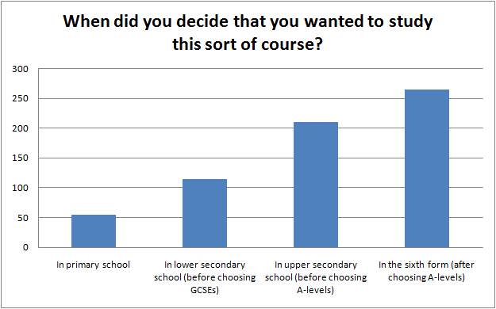
Comment: Early choice allows time for steady preparation for a course.
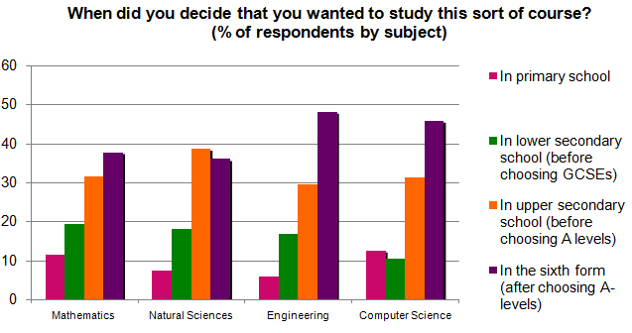
Further analysis: What effect does early choice have on success?
- There was strong evidence that acceleration in primary and secondary accelerated choice (r, s) = (~0.25, 0.001)
- There was significant evidence that early choice was made by those who perceived themselves to be strong at maths at primary school (r, s) = (0.22, 0.04)
- There was strong evidence that early choice was made by those who subsequently perceived themselves to have good understanding of university level mathematics (r, s) = (0.21, 0.006)
Conclusion: Many respondents chose their university course early in their school career. Such respondents tended to consider themselves to be strong at mathematics, tended to have been accelerated and tended do better in part II.

Type of schools attended
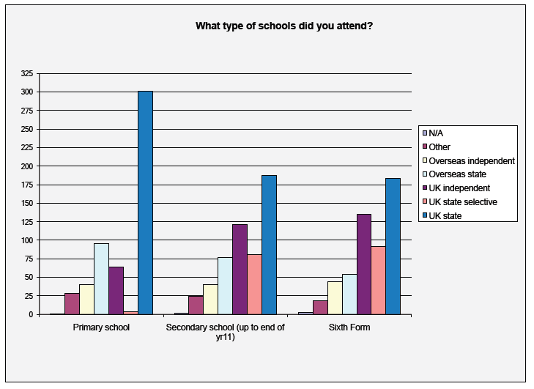
Comment: Schooling data received was unexpectedly complicated; the next study will be more focussed concerning this point, should school-type prove relevant.
160 respondents were comprehensive-schooled (excluding selective and grammar) at both Secondary and 6th form. 116 respondents were independent-schooled at both secondary and sixth-form, which are analysed as COMPREHENSIVE and INDEPENDENT groups throughout the analysis.
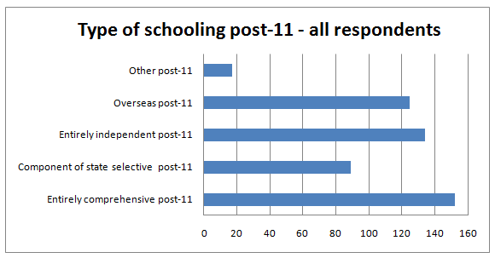
Conclusion: The survey drew response from an acceptably representative sample of schools
Notably there were no statistical difference in university grade profile between COMPREHENSIVE and INDEPENDENT schooled respondents.
Statistical differences leading to at least a half point difference in average score were as follows:
t-stat | COMP | IND | Diff | Factor
1.77E-17 | 1 | 2.405172 | 1.41 | Type of primary school attended
0.000159 | 2.03 | 1.08 | 0.95 | TEACHING MEASURE - Supportive or approachable - Primary school
9.48E-07 | 2.53 | 3.48 | 0.95 | Measure of STEP support
4.43E-05 | 2.44 | 1.54 | 0.90 | Influence Further Mathematics support programme
0.001259 | 2.67 | 1.84 | 0.83 | Useful: Further Mathematics support programme
2.88E-05 | 1.26 | 2.05 | 0.80 | TEACHING MEASURE - Extended the mathematics beyond the curriculum - Sixth form
2.21E-05 | 0.71 | 1.30 | 0.59 | TEACHING MEASURE - Extended the mathematics beyond the curriculum - Secondary school (up to end of yr11)
0.000634 | 0.79 | 1.32 | 0.53 | Total Influence Guest presenters at school
0.001523 | 2.75 | 3.28 | 0.53 | Useful: Secondary school teachers
0.018035 | 2.62 | 3.14 | 0.52 | Measure of good teaching - Secondary
0.012116 | 1.49 | 0.98 | 0.51 | TEACHING MEASURE - Made learning fun and enjoyable - Primary school

Conclusions: Significant differences existed between INDEPENDENT and COMPREHENSIVE respondents in terms of STEP support, the importance of the Further Mathematics Support Programme and aspects of the teaching received: INDEPENDENT schooled respondents received significantly more enrichments and extension post-11 and better teacher post-11; COMPREHENSIVE students had a more supportive and enjoyable primary school experience.
There were no significant differences between these groups concerning any aspects of university experience, including realised grades.
Comment: School-type appears not to be a direct factor of importance in this study. More important is the received teaching.

Comparison of respondents by school type
A clear story emerges in differences between independent and comprehensive UK schooled respondents as the following table, which contains all statistically significant differences between the responses for the two groups, shows:

Gender
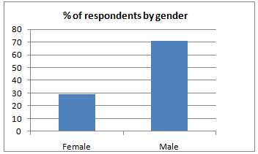

Statistical differences between male and female responses
The responses were compared between Male and Female respondents, seeking for 5% significant differences of at least half a point in responses.
A very interesting social difference occurred: twelve factors emerged as significantly leading to at least a half point swing in the responses and all of these related to measures of school teaching received: Females rated each factor concerning received school teaching , on average, significantly more positively than Males.
Conclusion: Female respondents rated their received school teaching far more positively than Male respondents - this point is worthy of further analysis.

Students reporting disability
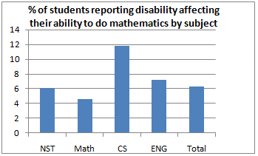
Some interesting statistical differences arose between the respondents reporting disability affecting their ability to learn mathematics and those not reporting such a disability. Those differences leading to at least a 0.5 difference in average (along with the impact on 1A for interest; no differences were observed for parts IB and II) were as follows:
t-stat | DIS | Non-DIS | Diff
0.01 | 2.7 | 2.0 | 0.7 | Influence School mathematics clubs
0.04 | 2.8 | 2.1 | 0.7 | Useful: Holiday mathematics programmes
0.01 | 3.9 | 3.2 | 0.6 | Influence The Internet
0.02 | 3.3 | 2.6 | 0.6 | Influence Visits to places of interest
0.05 | 1.0 | 1.6 | -0.6 | Useful: NRICH website
0.01 | 3.2 | 2.7 | 0.6 | Maths difficulties: Remembering formulae
0.02 | 2.7 | 3.1 | -0.4 | 1A grade (no differences observed for IB and II grades)

Comment: Students reporting disabilities affecting their ability to learn mathematics tended to be influenced by external factors and were affected by memory in terms of remembering formulae.

Ethnic Background
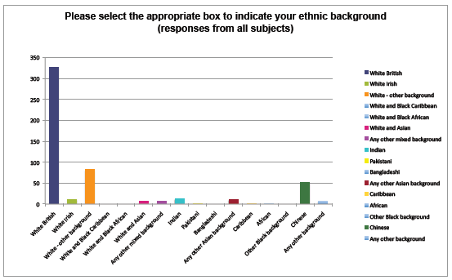
Several significant differences were observed between the two groups White British and Not (White British) shown here (along with the impact on 1A for interest; no differences were observed for parts IB and II)
t-stat | WB | NWB | DIFF
1E-37 | 3.1 | 1.3 | 1.8 | TEACHING MEASURE - Were mathematically capable - Sixth form
1E-30 | 2.7 | 1.2 | 1.5 | TEACHING MEASURE - Supportive or approachable - Sixth form
2E-32 | 2.6 | 1.1 | 1.5 | TEACHING MEASURE - Explained things clearly - Sixth form
8E-07 | 8.4 | 6.9 | 1.4 | # A*s or top grades
4E-28 | 2.1 | 0.8 | 1.2 | TEACHING MEASURE - Inspiring or enthusiastic - Sixth form
9E-25 | 2.0 | 0.8 | 1.2 | TEACHING MEASURE - Stretched my ability - Sixth form
2E-26 | 1.9 | 0.8 | 1.2 | TEACHING MEASURE - Made learning fun and enjoyable - Sixth form
1E-05 | 7.7 | 6.5 | 1.2 | # GCSEs or equivalent
1E-16 | 2.4 | 1.2 | 1.1 | TEACHING MEASURE - Were mathematically capable - Secondary school (up to end of yr11)
2E-13 | 1.9 | 1.0 | 0.9 | TEACHING MEASURE - Supportive or approachable - Secondary school (up to end of yr11)
2E-12 | 1.5 | 0.7 | 0.8 | TEACHING MEASURE - Extended the mathematics beyond the curriculum - Sixth form
4E-13 | 1.5 | 0.7 | 0.8 | TEACHING MEASURE - Provided enrichment opportunities - Sixth form
2E-10 | 1.8 | 1.1 | 0.7 | TEACHING MEASURE - Explained things clearly - Secondary school (up to end of yr11)
2E-07 | 1.6 | 0.9 | 0.7 | TEACHING MEASURE - Supportive or approachable - Primary school
2E-03 | 4.2 | 3.6 | 0.6 | Measure of good teaching - Sixth form
5E-09 | 4.3 | 3.7 | 0.6 | Total Influence Sixth form teachers
1E-09 | 1.2 | 0.7 | 0.5 | TEACHING MEASURE - Made learning fun and enjoyable - Secondary school (up to end of yr11)
4E-06 | 1.2 | 0.7 | 0.5 | TEACHING MEASURE - Made learning fun and enjoyable - Primary school
1E-05 | 3.1 | 3.6 | -0.5 | Total Influence Wider reading
3E-04 | 2.4 | 2.9 | -0.5 | Total Influence Mathematics competitions
6E-09 | 0.8 | 1.6 | -0.7 | Total Influence School mathematics clubs
0.002 | 2.9 | 3.2 | -0.3 | 1A grade (no differences observed for IB and II grades)

Conclusion: White British respondents had received significantly better teaching and results at GCSE than Non-(White British) respondents. Non-(White British) respondents were significantly more influenced by external factors.
Comment: This is a very important result in the context of the wider research programme of reaching exceptionally gifted students from all backgrounds.

Profiles by grade, gender and school
We considered breakdown by subject, school-type and gender. The latter categories are included because these are traditionally reported in statistics of university entrance and performance. although the research was not conducted with any preconception concerning these groups. The school-type data receive was varied and complicated, so we defined INDEPENDENT schooled to mean independent-schooled for both secondary and 6th form; we define COMPREHENSIVE to mean comprehensive-schooled for both secondary and 6th forms - these are the commonly perceived 'extremes' of schooling in the UK and, hence, a useful measure in the consideration of impact of schooling on student outcomes. The following table shows the numbers of respondents falling into each category:
COUNTS | TOTAL | INDEP | COMP | MALE | FEMALE
NS | 174 | 36 | 56 | 100 | 44
MATHS | 204 | 25 | 55 | 124 | 37
CS | 38 | 8 | 6 | 23 | 6
ENG | 207 | 45 | 45 | 107 | 66

Broken down by gender and Comprehensive/Independent school, the IA grades achieved become
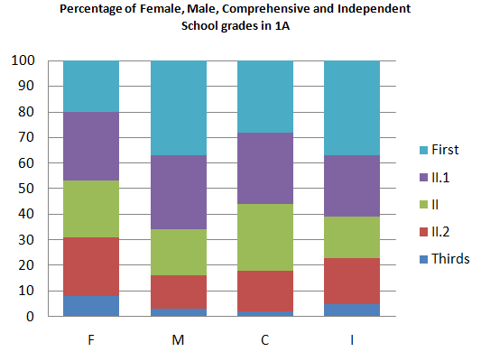

Section B: Examinations taken
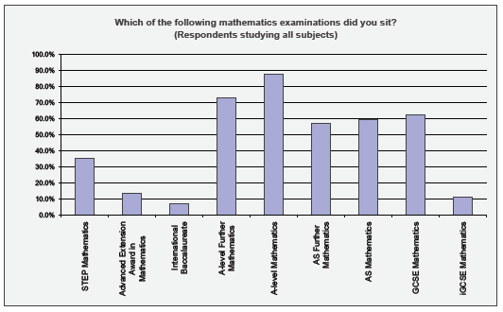

Further mathematics opportunities which were available
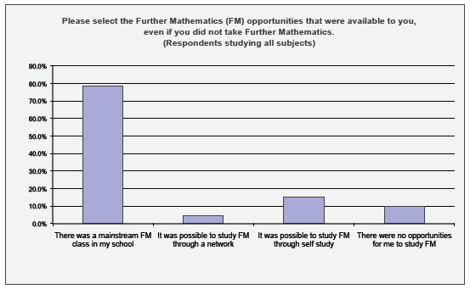

STEP opportunities which were available

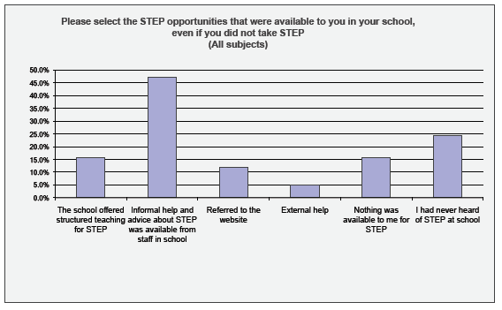
STEP and FM support
We analysed the impact of the amount of STEP/FM support received for maths students, and defined a 'Measure of STEP support' and a ‘Measure of FM support’ ranging from 0 (no support) to 5 (mainstream lessons provided). Many of the same factors emerged at the 5% significance level for both STEP and FM provision, and clearly showed the importance of the teacher.
 | STEP | FM
TEACHING MEASURE - Were mathematically capable - Sixth form | 0.42; 0.00 | 0.17; 0.00
Useful: Sixth form teachers | 0.37; 0.00 | 0.17; 0.00
TEACHING MEASURE - Explained things clearly - Sixth form | 0.35; 0.00
TEACHING MEASURE - Extended the mathematics beyond the curriculum - Sixth form | 0.31; 0.00 | 0.10; 0.05
TEACHING MEASURE - Supportive or approachable - Sixth form | 0.30; 0.00 | 0.11; 0.03
TEACHING MEASURE - Stretched my ability - Sixth form | 0.30; 0.00 | 0.13; 0.01
TEACHING MEASURE - Made learning fun and enjoyable - Sixth form | 0.25; 0.00 | 0.15; 0.00
TEACHING MEASURE - Provided enrichment opportunities - Sixth form | 0.22; 0.01 | 0.11; 0.04
# A*s or top grades | 0.21; 0.01
TEACHING MEASURE - Were mathematically capable - Secondary school | 0.20; 0.02
Total Influence Visits to places of interest | 0.20; 0.01
Total Influence Sixth form teachers | 0.19; 0.03 | 0.13; 0.01
TEACHING MEASURE - Inspiring or enthusiastic - Sixth form | 0.19; 0.02 | 0.15; 0.00
TEACHING MEASURE - Extended the mathematics beyond the curriculum - Primary school | 0.18; 0.03
Total Influence Guest presenters at school | 0.18; 0.03
Total Influence Mathematics competitions |  | 0.14; 0.01
# Influences on Course |  | 0.13; 0.01
Useful: School mathematics clubs |  | 0.13; 0.05
In hindsight, would more intervention have helped you with uni maths? |  | 0.13; 0.01
TEACHING MEASURE - Provided enrichment opportunities - Secondary school (up to end of yr11) |  | 0.12; 0.02
TEACHING MEASURE - Supportive or approachable - Secondary form |  | 0.13; 0.01

Comment: Very notably, there was a significant negative relationship between the amount of STEP support received at school and the grade in part II for the respondents (-0.61) - this is worthy of further analysis.

Section C: Influences and preparedness for university course

Influences of key factors on choice of type of course

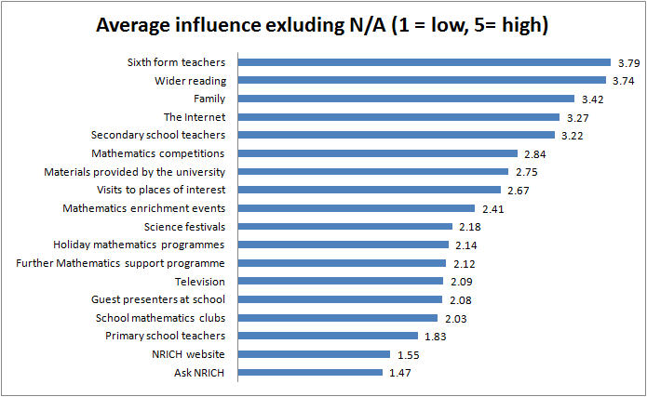
It is important to note that these are influences on the choice of university course. Influences recorded as not applicable are shown in the following table. From the structure of the questionnaire it is reasonable to suppose that such respondents had no exposure to these factors.
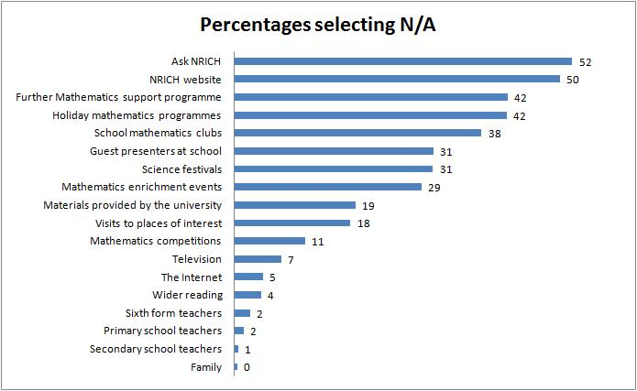

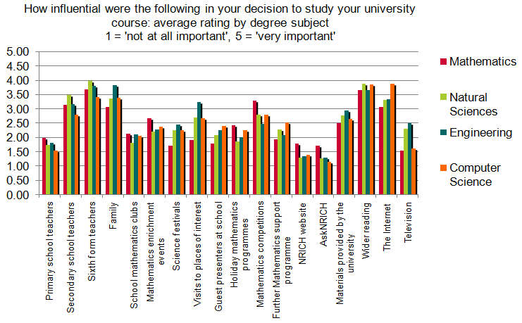

Usefulness of key factors in preparation for university course

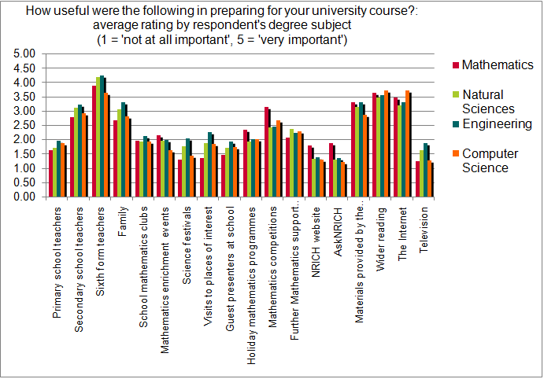

Influences in decision to study university course
The average influences in deciding a university course where a score was recorded were as follows:
Conclusion: Sixth form teachers, Wider Reading, Family, Internet, Secondary School Teachers were clearly perceived to be the key influences in choice of university course.

Do multiple influences/useful interventions boost grade?
To assess this, we considered how many interventions respondents received for which they scored 4s or 5s. The correlations between grades and particularly important uses and influences are in the following table.
 | Correlation vs IA grade | Correlation vs II grade
Useful 5s | -0.04 | 0.06
Total Influence 5s | 0.00 | 0.06
Useful 4/5s | -0.04 | 0.26
Total Influence 4/5s | -0.05 | 0.10
Sum of Useful | -0.02 | 0.25
Sum of Total influence | -0.03 | 0.18

Conclusion: There were no significant relationships between the number of interventions and realised grades at IA but there was a significant (positive) relationship between the number of useful preparations and part II.

What schools do well prepared respondents come from?
544 respondents gave information about all stages of schooling and data on total influence and useful preparation. Since school data was complex, we looked at the data for OVERSEAS, INDEPENDENT and COMPREHENSIVE schooled post 11.
 | Count per INDEPENDENT student | Count per COMPREHENSIVE student | Count per OVERSEAS student
Useful 5s | 1.66 | 1.70 | 2.17
Total Influence 5s | 1.63 | 1.91 | 1.84
Useful 4/5s | 3.87 | 3.87 | 4.50
Total Influence 4/5s | 4.32 | 4.38 | 4.28
Total Useful | 33.6 | 33.6 | 36.6
Total Impact of Influences | 34.0 | 34.6 | 36.0

Conclusion: There was little difference between the amount of useful or influential preparation received by UK schooled respondents, but overseas respondents received notably more Useful preparation.

Useful preparations for university course
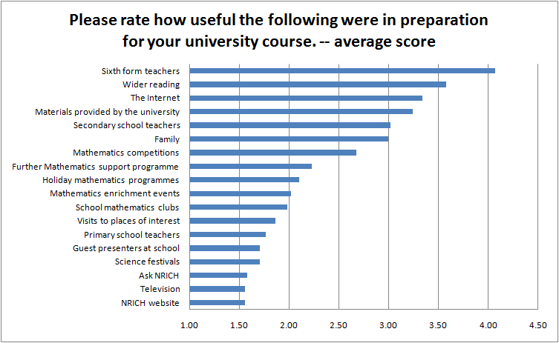
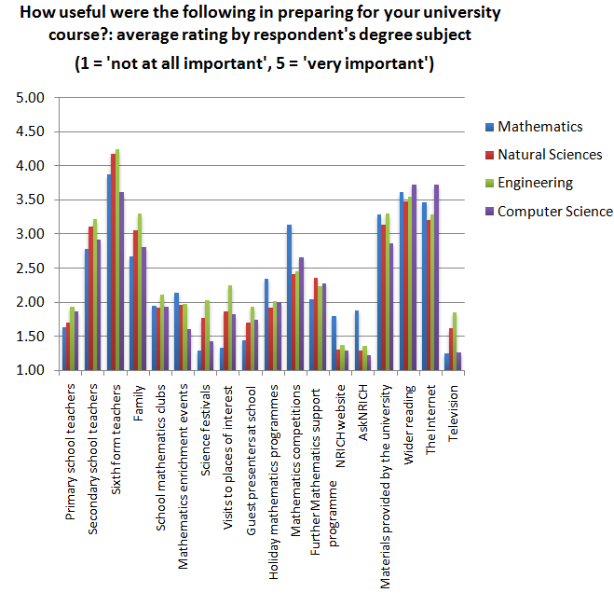
Conclusion: Sixth form teachers, Wider Reading, Internet, Materials Provided By The University and Secondary School Teachers and Family were perceived to be the most useful preparation for university course.
Comment: In order to understand the possible impact of an intervention or preparation it is important to determine which interventions are actually useful to which respondents.
We analysed whether these influences and useful preparation translated into improved grades at university. The following table shows the correlations of interventions with grades IA , IB and part II. Those figures significant at 0.05 or greater are shown in bold; the red indicates a positive correlation.
See table for data
We could find few significant correlations between individual useful preparations grades for subjects considered collectively. However, note that of the 18 resources under question the correlation with IA grade is positive for only 2 of these, 7 are positive for part IB grade and 17 are positive for part II grade. There is also an overall strong patter of increase is correlation from year to year for each factor. A full analysis by subject showed a similar pattern. This does provide some evidence, worthy of further investigation, for the following statements:
- Overall, students with very little pre-university preparation may do slightly better on average in part IA
  - Might we conjecture that students with little useful preparation need to demonstrate intelligence or resourcefulness to win their places; students with lots of useful preparation might win a place over a more talented but less well prepared counterpart?
- Overall, students with lots of useful pre-university preparation do better in part II
  - Might we conjecture that useful pre-university preparation gives students the 'staying power and solid grounding' to do well at part II as well as helping them to get onto the course in the first place?
- The table provides interesting school difference concerning useful preparation: It gives some evidence that independent school teaching propagated through to success in part II, whereas the impact of useful school teaching preparation had little impact on comprehensive schooled respondents.
- There is some evidence that those preparations which focus on the social aspects of mathematics lead to sustained improvement in tripos

Conclusion: These seem to be very important insights, worthy of significant further investigation

 | ALL |  |  | MALE |  |  | FEMALE |  |  | COMPREHENSIVE |  |  | INDEPENDENT
 | IA | IB | II | IA | IB | II | IA | IB | II | IA | IB | II | IA | IB | II
Useful: Primary school teachers | -0.03 | -0.02 | 0.22 | 0 | 0.07 | 0.23 | -0.12 | -0.33 | 0.16 | -0.05 | -0.06 | 0.14 | -0.07 | -0.12 | 0.45
Useful: Secondary school teachers | -0.03 | 0.01 | 0.08 | -0.01 | 0.1 | 0.02 | -0.14 | -0.15 | 0.06 | -0.09 | 0.12 | 0.05 | -0.03 | 0.03 | 0.26
Useful: Sixth form teachers | -0.08 | -0.06 | -0.09 | -0.08 | -0.02 | -0.06 | -0.23 | -0.27 | -0.13 | -0.12 | 0.04 | -0.19 | 0.18 | 0.04 | 0.63
Useful: Family | -0.03 | -0.03 | 0.1 | -0.03 | 0.12 | 0.06 | -0.08 | -0.3 | 0.04 | -0.08 | 0.14 | 0 | 0.07 | -0.01 | 0.13
Useful: School mathematics clubs | 0 | -0.01 | 0.2 | 0.03 | 0.07 | 0.16 | -0.04 | -0.13 | 0 | 0.05 | 0.05 | 0.1 | 0.06 | -0.18 | -0.67
Useful: Mathematics enrichment events | -0.02 | 0.01 | 0.19 | 0.01 | -0.03 | 0.15 | -0.01 | 0.22 | 0.21 | -0.08 | -0.12 | 0.09 | 0.07 | 0.09 | -0.15
Useful: Science festivals | -0.03 | 0.08 | 0.26 | -0.01 | 0.12 | 0.31 | -0.14 | 0.11 | -0.11 | -0.15 | 0 | -0.54 | 0.12 | 0.31 | 0.51
Useful: Visits to places of interest | -0.09 | -0.05 | 0.08 | -0.02 | 0.02 | -0.03 | -0.19 | -0.05 | 0.05 | -0.2 | -0.03 | -0.5 | 0.1 | 0.1 | 0.16
Useful: Guest presenters at school | -0.03 | -0.05 | 0.09 | 0.02 | -0.14 | -0.06 | -0.09 | 0.02 | 0.4 | -0.06 | -0.05 | -0.77 | 0.12 | -0.01 | 0.23
Useful: Holiday mathematics programmes | -0.06 | 0.14 | 0.34 | 0.02 | 0.12 | 0.38 | -0.15 | 0.18 | 0.13 | -0.25 | 0.04 | -0.24 | -0.05 | 0.23 | 0.22
Useful: Mathematics competitions | 0.06 | 0.1 | 0.36 | 0.06 | 0.02 | 0.39 | -0.03 | 0.15 | 0.29 | 0.09 | -0.06 | 0.18 | 0.09 | 0.25 | 0.25
Useful: Further Mathematics support programme | 0 | -0.12 | 0.17 | -0.03 | -0.17 | 0.15 | 0.11 | -0.11 | 0.21 | 0.11 | -0.09 | -0.02 | 0.07 | -0.05 | 0.61
Useful: NRICH website | -0.07 | -0.01 | 0.04 | -0.08 | 0.07 | 0.07 | -0.02 | 0.02 | 0.11 | 0.14 | 0.17 | -0.05 | -0.06 | -0.05 | -0.52
Useful: Ask NRICH | -0.06 | -0.06 | 0.14 | -0.09 | 0 | 0.15 | 0.07 | 0.01 | 0.14 | 0.05 | 0.07 | 0.03 | 0.06 | -0.22 | -0.6
Useful: Materials provided by the university | -0.11 | 0.05 | 0.15 | -0.09 | 0.08 | 0.06 | -0.14 | 0.11 | 0.58 | -0.16 | 0.07 | -0.07 | 0.03 | 0.06 | -0.63
Useful: Wider reading | 0.04 | 0.05 | 0.17 | 0.03 | 0.06 | 0.03 | 0 | 0.17 | 0.32 | 0.03 | -0.06 | -0.01 | 0.02 | 0.07 | -0.23
Useful: The Internet | -0.06 | -0.02 | 0.26 | -0.08 | -0.06 | 0.24 | -0.01 | 0.06 | 0.29 | -0.07 | -0.09 | 0.11 | 0.02 | -0.13 | 0.25
Useful: Television | -0.03 | -0.03 | 0.05 | -0.03 | -0.06 | -0.11 | 0.03 | 0.03 | 0.4 | -0.06 | 0.07 | -0.13 | 0.11 | -0.03 | 0.14

Would any additional support or intervention have helped in hindsight?
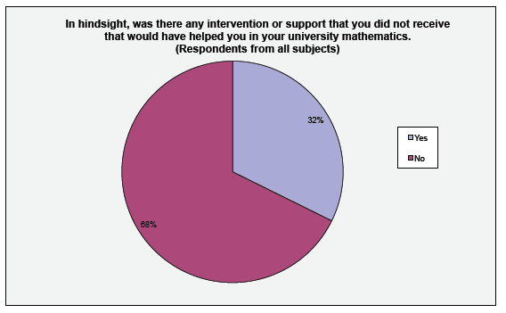
There was very strong evidence that being content in hindsight was at best weakly correlated with the number of key moments (r, s) = (-0.16, 0.000).
Factor to correlate with 'In hindsight was additional intervention wanted' | (r, s)
TEACHING MEASURE - Extended the mathematics beyond the curriculum - Sixth form | 0.17; 0.00
Your enjoyments of maths: university | 0.16; 0.00
1A grade | 0.14; 0.01

Conclusion: One third of respondents felt that they could have been helped more. Respondents who had been exposed to acceleration, extension and enrichment were more likely not to have wanted additional help in hindsight.

Section D: Concerning teaching received

Influential or inspiring teachers
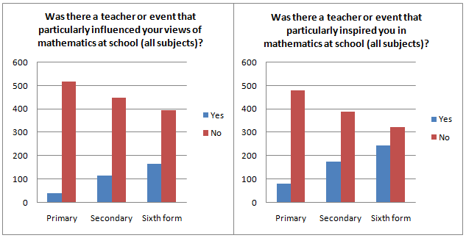
Further analysis showed that 61% of both Independent and comprehensive schooled respondents had their views of mathematics particularly influenced by a teacher or event. Furthermore, 63% of Independent schooled and 62% of comprehensive schooled respondents were particularly inspired at some stage by a teacher or event. UK school type appeared to play no part in inspiration.
Note: Being inspired by a teacher seemed only slightly increases enjoyment of maths
Conjecture: There is no point being inspired if the tasks undertaken in lessons are not inspiring. The in-lesson tasks are crucial.
We analysed the combination of influence/inspiration at each stage, with results as follows:
 |  |  | Total stages of education in which a teacher or an event influenced views of maths
 |  |  | 0 | 1 | 2 | 3
Total stages of education in which there was an inspirational teachers or event |  | 0 | 220 | 35 | 5 | 0
 |  | 1 | 84 | 63 | 8 | 3
 |  | 2 | 40 | 20 | 49 | 3
 |  | 3 | 12 | 6 | 5 | 16

Conclusion: Around one third of respondents reported no influential or inspirational teachers or events (concerning mathematics) during their entire educational experience. UK School type played little part in inspiration or influence concerning mathematics.

Memorable mathematics teachers
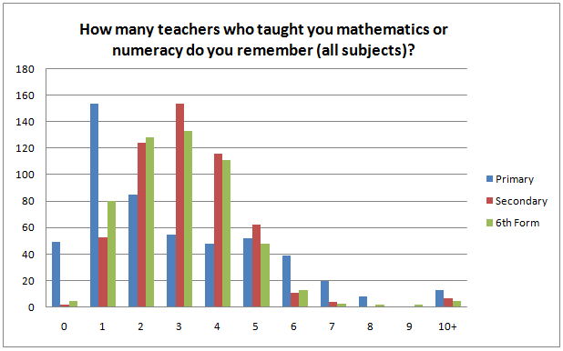

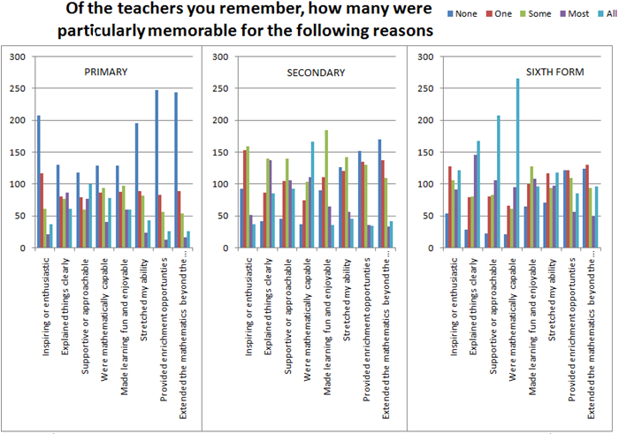

Conclusions: There were significant numbers of memorable primary teachers. There were significant numbers of non-memorable secondary and sixth form teachers.

Effects of 'good' mathematics teaching
We defined a 'Measure of good teaching' by summing these totals scored for each of the memorable teaching categories. Significant correlations at 5% are as follows
Factor to correlate with 'Overall Measure of Good Teaching' | (r, s)
Total Influence Secondary school teachers | 0.33; 0.00
Total Influence Sixth form teachers | 0.33; 0.00
Total Influence Primary school teachers | 0.29; 0.00
Useful: Sixth form teachers | 0.26; 0.00
Useful: Secondary school teachers | 0.20; 000
Your enjoyments of maths: secondary | 0.20; 0.00
Your enjoyments of maths: sixth form | 0.18; 0.00
Your enjoyments of maths: primary | 0.17; 0.00
In hindsight, your appreciation of mathematics: sixth form | 0.16; 0.00
In hindsight, your appreciation of mathematics: secondary | 0.15; 0.00
Accelerated? Sixth form (NB this means 'those with good teaching were accelerated') | -0.14; 0.00
Accelerated? Primary School (as above) | -0.17; 0.00
Accelerated? Sec school (as above) | -0.17; 0.00

There is strong evidence from the survey that good teaching of any time leads to influential teachers and enjoyment of mathematics, as follows:

‘Good’ teachers are influential
42 | 0.001 | ALL | Measure of good teaching - Primary v Total Influence Primary school teachers
41 | 0.001 | ALL | Measure of good teaching – Secondary v Total Influence Secondary school teachers
21 | 0.001 | ALL | Measure of good teaching - Sixth form v Influence Sixth form teachers

'Good' teaching makes maths more enjoyable
25 | 0.001 | ALL | Your enjoyment of maths: primary v Measure of good teaching - Primary
28 | 0.001 | ALL | Your enjoyment of maths: secondary v Measure of good teaching - Secondary

Conclusion: From the data gathered there was very strong evidence that good teaching increases enjoyment, interest, positive views of mathematics and the total influence and perceived usefulness of teachers

Acceleration
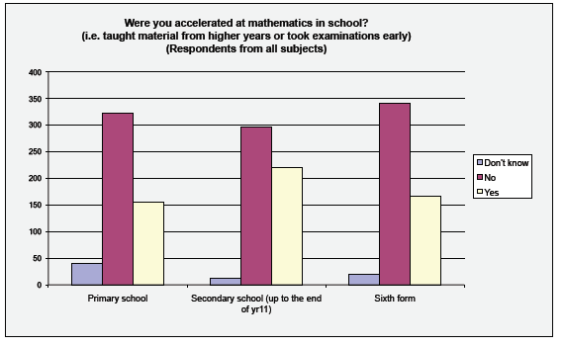
Respondents who were accelerated in primary school were positively (-0.2) influenced by primary teachers, had good (-0.2) perceptions of their primary school ability (-0.2) considered their teachers good, appreciated mathematics (-26) and (-0.2) enjoyed mathematics.
Acceleration in secondary school positively impacted: good teaching, levels of enrichment, extending the curriculum, mathematics was made fun, mathematics was made enjoyable (correlations between -0.2 and -0.25 for each of these)
Respondents who were accelerated in sixth form (-15) felt stretched, (-17) felt enriched, were (-21) extended beyond curriculum, felt more (-16) able, found maths (-16) easy, were more interested (-13) in mathematics.
Throughout the analysis, enrichment and acceleration tended to have the same impact: they appeared to go hand in hand from the data gathered.
Conclusion: Acceleration was clearly perceived to be a good thing from the data gathered. Acceleration levels seemed to be strongly related to enrichment levels.
Comment: What would the perceptions of less able accelerated students be?

Additional mathematics support outside of lessons
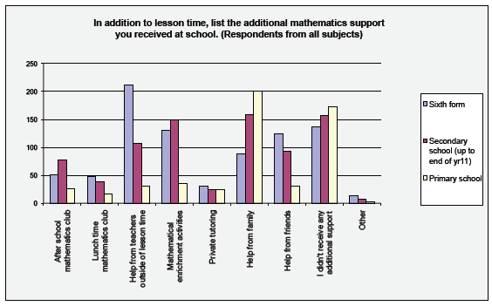
Percentages of student receiving no additional mathematics support at each stage
Primary | Secondary | Sixth form
33 | 30 | 26
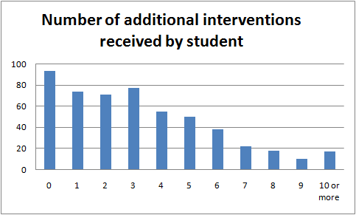
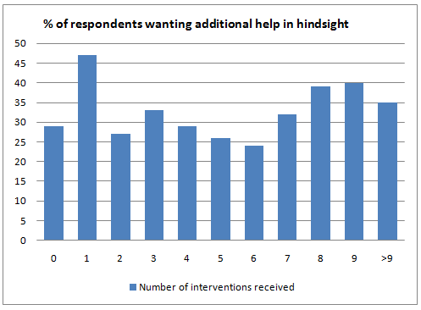
Respondents Independent-schooled post-11 received an average of 4.01 additional interventions
Respondents Comprehensive-schooled post-11 received an average of 4.04 additional interventions
For those 167 who received just 0 or 1 additional intervention, 103 didn’t want additional help in hindsight; 62 did, as shown in the following table:
The number of additional interventions received outside of lesson time appeared to have no impact on students performance:
Conclusion: Large numbers of respondents had received no additional mathematics support outside of lesson time; the amount of support received seemed to be independent of school type; there was no evidence of additional interventions received by respondents leading to improved performance or improved contentedness in hindsight; in hindsight around 1/3 respondents wanted an intervention, irrespective of the amount of additional mathematics help they had received outside lessons

Amount of mathematics learned

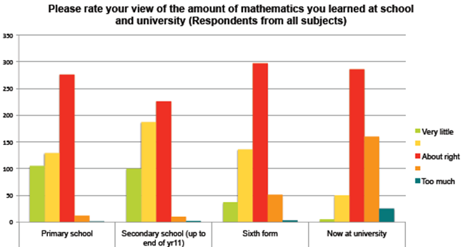

Amount of support received at school and university
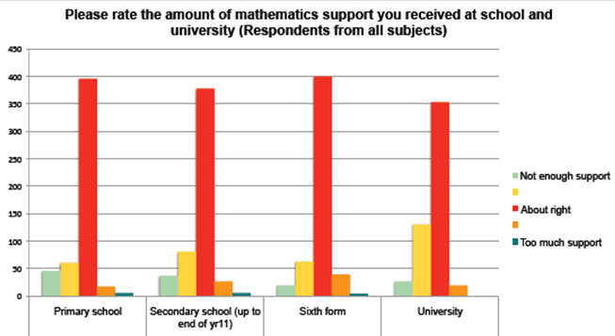

Conclusion: One third of respondents felt that they need more mathematics support at university than they get; around one fifth of respondents felt that they had needed more support whilst at school.

Section E: Perceptions of Mathematics

Views of mathematics

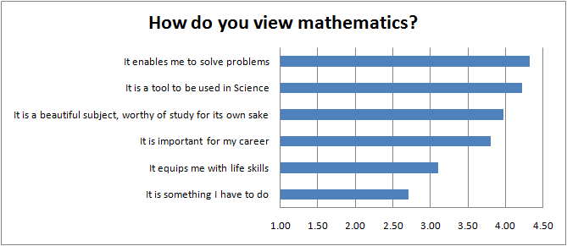
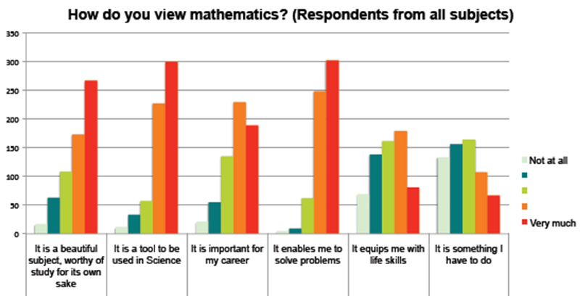

Notes: Views of mathematical ability were reasonably static from primary to secondary.
Views of the importance of mathematics from 6th Form to university were very static.
Those who saw mathematics as a beautiful subject tended to enjoy mathematics and find it easier to maintain interest in both Engineering and the Sciences.

Conclusion: There was generally a high appreciation of the importance and beauty of maths across all STEM subjects.

Importance of mathematics

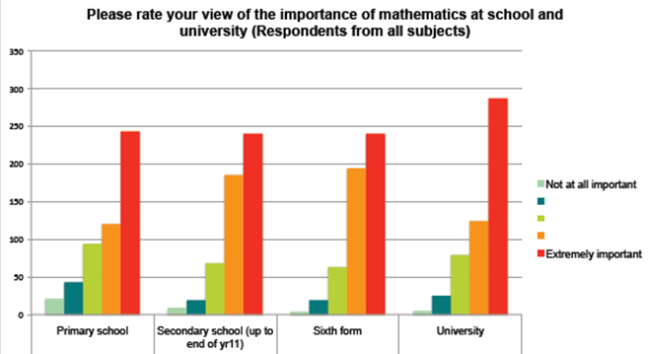

Interest in mathematics

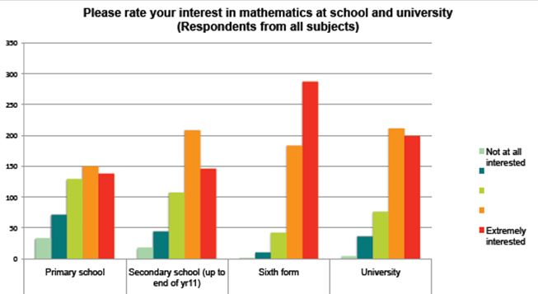

Enjoyment of mathematics
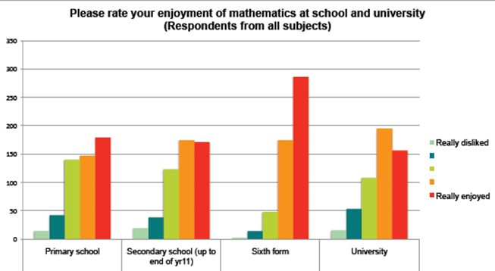

Note: Interest, enjoyment and appreciation of mathematics were strongly related across all stages of education.

Understanding of mathematics

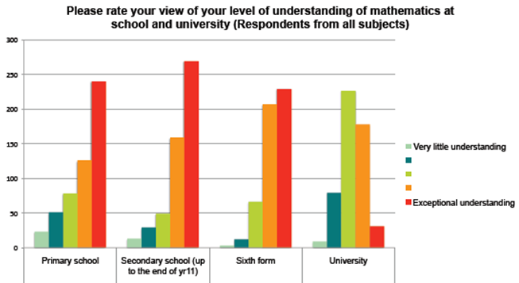

Section F: Doing Mathematics

Ways of learning
There was a good response rate to the learning-style question: around 620 responses were given to each question.

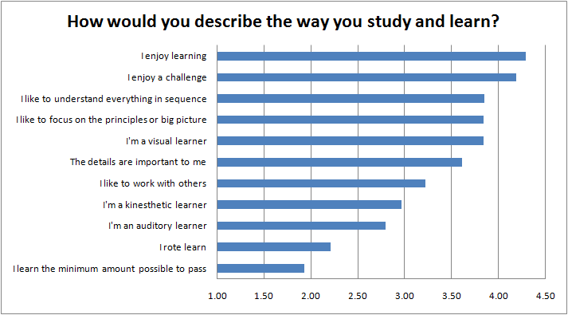
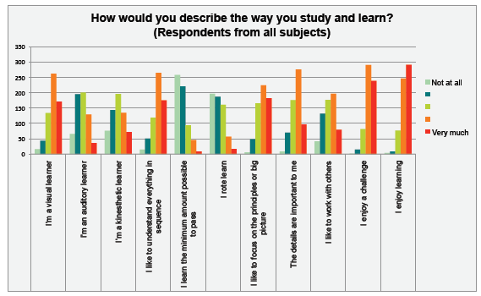
We also analysed how many respondents reported a strong preference for each response:

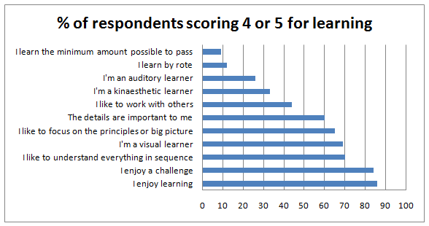

This gave a pleasing picture of respondents' attitudes to learning.

Conclusions: Respondents enjoyed learning and enjoyed a challenge although, notably, 14% of respondents do not particularly enjoy learning and 16% do not enjoy a challenge; Linear (sequential) vs. non-linear (big-thinker) thinkers were present in equal measures; Visual learners were a significant majority.

The learning preferences correlate with achieved grades as follows:
 | Visual | Auditory | Kin | Sequential | Min possible | Rote learning | Big picture
IA grade | -0.1 | -0.1 | -0.1 | 0.0 | -0.3 | -0.1 | 0.1
IB grade | -0.1 | -0.1 | -0.1 | -0.1 | -0.4 | -0.1 | 0.0
II grade | 0.2 | 0.1 | 0.1 | -0.1 | -0.2 | -0.2 | 0.2

Conclusion: There is evidence that, overall, highly visual learners performed slightly better in part II; as do big picture learners. All-rounders seem to have performed slightly better in part IA. There is evidence that learning by rote and learning the minimum possible to pass have a negative impact on grades.

Note: There was little evidence that learning preference affects views of maths or what makes a good maths question.

Conclusion: There was very little difference in learning preferences between respondents across STEM subjects, gender or school-type. The most significant difference in learning preference concerned preference working with others.

Difficulties in doing mathematics

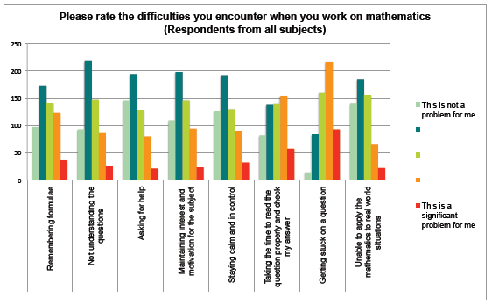
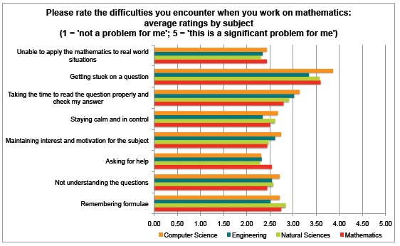

Difficulties encountered when working on mathematics.

1 = Not at all a problem; 5 = significant problem | % Scoring 1 or 2 | % scoring 4 or 5
Getting stuck on a question | 17 | 54
Taking the time to read the question properly and check my answer | 39 | 37
Remembering formulae | 47 | 28
Staying calm and in control | 56 | 21
Maintaining interest and motivation for the subject | 54 | 21
Not understanding the questions | 55 | 20
Asking for help | 59 | 18
Unable to apply the mathematics to real world situations | 57 | 15

Individually analysed we find:
 | Maths difficulties: Remembering formulae | Maths difficulties: Not understanding the questions | Maths difficulties: Asking for help | Maths difficulties: Maintaining interest and motivation for the subject | Maths difficulties: Staying calm and in control | Maths difficulties: Taking the time to read the question properly and check my answer | Maths difficulties: Getting stuck on a question | Maths difficulties: Unable to apply the mathematics to real world situations
ENG | 2.3 | 2.3 | 2.1 | 2.4 | 2.1 | 2.7 | 3.0 | 2.1
CS | 2.4 | 2.6 | 2.1 | 2.5 | 2.5 | 3.0 | 3.5 | 2.3
MATHS | 2.3 | 2.1 | 2.1 | 2.0 | 2.1 | 2.4 | 3.0 | 2.1
NST | 2.6 | 2.3 | 2.0 | 2.2 | 2.4 | 2.6 | 3.2 | 2.1
OVERSEAS | 2.9 | 2.4 | 2.2 | 2.4 | 2.5 | 2.7 | 3.4 | 2.4
INDEPT | 2.9 | 2.4 | 2.4 | 2.6 | 2.4 | 3.2 | 3.4 | 2.4
COMP | 2.5 | 2.6 | 2.3 | 2.5 | 2.6 | 3.0 | 3.6 | 2.4
MALE | 2.7 | 2.4 | 2.3 | 2.5 | 2.4 | 2.9 | 3.5 | 2.3
FEMALE | 2.6 | 2.8 | 2.4 | 2.6 | 2.6 | 2.9 | 3.6 | 2.6

Conclusion: Biggest problem areas for respondents were getting stuck, not reading the question or checking the answer and not remembering formulae.

Important aspects of mathematics questions

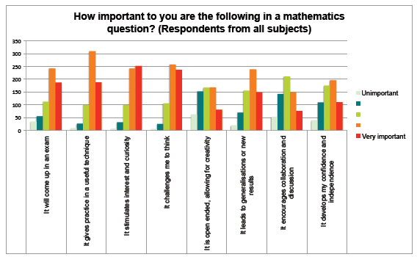 Important features of a maths question

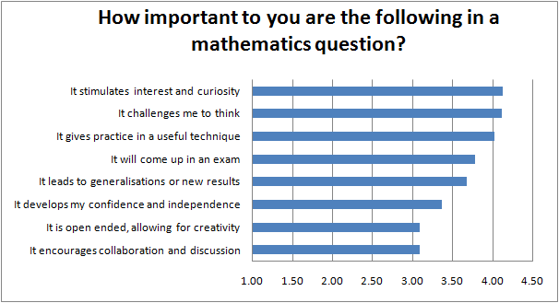
We analysed the proportions of respondents rating each question low of highly.
 | % given 1,2 | % giving 4,5
It encourages collaboration and discussion | 31 | 36
It is open ended, allowing for creativity | 34 | 40
It develops my confidence and independence | 23 | 49
It leads to generalisations or new results | 14 | 62
It will come up in an exam | 14 | 68
It gives practice in a useful technique | 5 | 79
It challenges me to think | 5 | 78
It stimulates interest and curiosity | 6 | 79

Conclusion: An interesting, stimulating challenge in a useful context was very important to respondents
The analysis on a subject-by-subject basis showed
 | It will come up in an exam | It gives practice in a useful technique | It stimulates interest and curiosity | It challenges me to think | It is open ended, allowing for creativity | It leads to generalisations or new results | It encourages collaboration and discussion | It develops my confidence and independence
ALL | 3.7 | 3.9 | 4.0 | 4.0 | 3.0 | 3.6 | 3.0 | 3.3
NST | 3.8 | 3.9 | 3.9 | 4.0 | 3.0 | 3.5 | 3.0 | 3.3
Maths | 3.5 | 3.8 | 4.3 | 4.2 | 3.3 | 3.9 | 3.1 | 3.3
CS | 3.7 | 3.9 | 4.0 | 3.9 | 3.0 | 3.4 | 2.8 | 3.2
Eng | 3.8 | 4.0 | 3.7 | 3.8 | 2.7 | 3.2 | 2.9 | 3.2
Spread | 0.3 | 0.2 | 0.6 | 0.4 | 0.6 | 0.7 | 0.3 | 0.2
OVERSEAS | 3.5 | 3.9 | 4.4 | 4.4 | 3.5 | 4.1 | 3.1 | 3.5
INDEPT | 3.7 | 3.9 | 4.1 | 4.0 | 3.0 | 3.4 | 2.9 | 3.2
COMP | 4.0 | 4.1 | 4.0 | 4.0 | 2.9 | 3.6 | 3.2 | 3.2
FEMALE | 4.0 | 4.1 | 4.0 | 4.0 | 2.8 | 3.4 | 3.1 | 3.5
MALE | 3.7 | 4.0 | 4.2 | 4.1 | 3.2 | 3.7 | 3.1 | 3.3

Conclusion: Stimulating and challenging were seen to be important factors which should be in a maths question, ideally one which leads to a new technique. Other factors were perceived to be neither good nor bad.

Self-views of mathematical ability
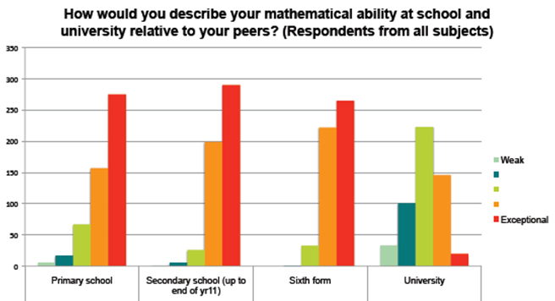

Difficulty of mathematics

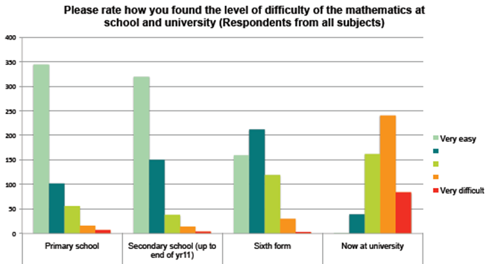
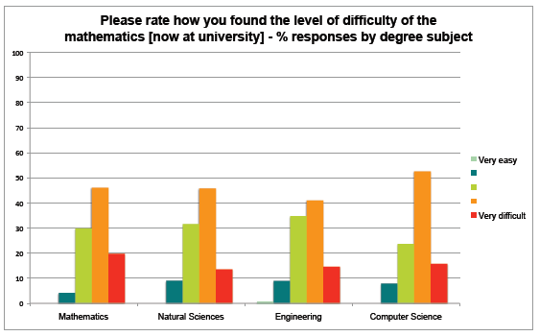

Section G: NRICH and Ask NRICH

Proportions of respondents who know they have used NRICH
36 used NRICH monthly or more, 43 yearly or more, 69 as one-off or more
24 used Ask NRICH monthly or more, 32 yearly or more, 48 at least once
Conclusions: The number of respondents who knew that they have used NRICH are lower than would be hoped; will our higher profile with next years' intake make a difference to this? Of the number of respondents who knew they have used NRICH or Ask NRICH 24% and 23% respectively used it at least once per month. This is a very pleasing statistic.

Section H: Overall

Key influences
This final question recorded the total influence on respondents' mathematics education and is, therefore, a key statistic in each response.
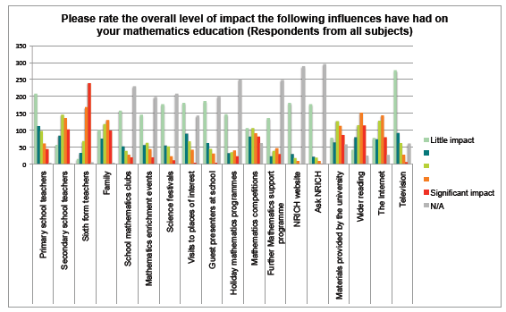
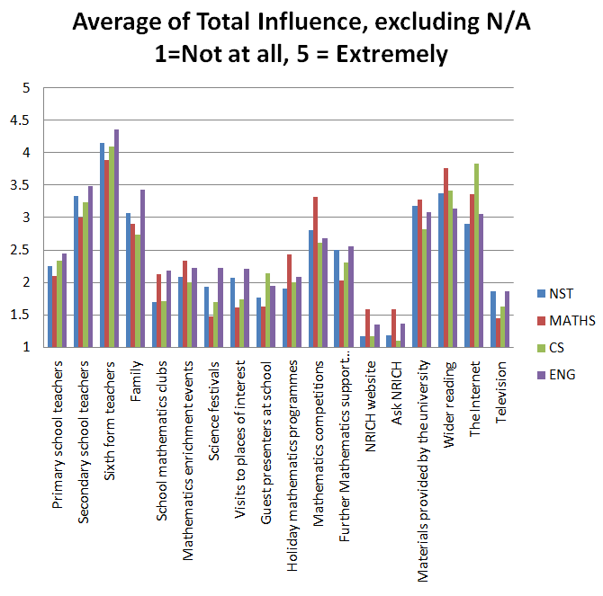

We analysed the exposure of the respondents to each of these potential influences, with results shown in the following table: (excluding teachers and family, which were almost universally relevant:
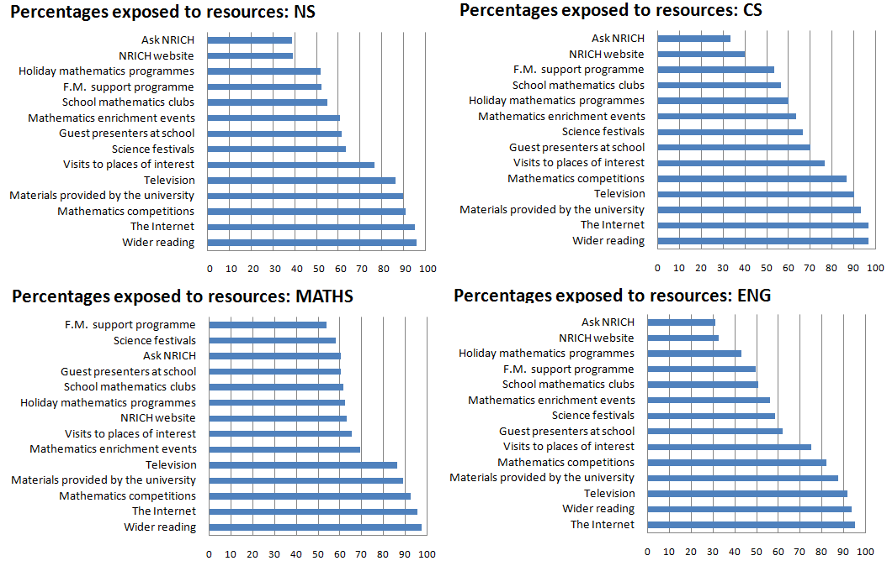
Conclusion: These charts show most notably that over 90% of respondents were exposed to mathematics competitions and that the overall exposure to the factors of those who subsequently chose to study mathematics were higher than in other subjects.

Key moments

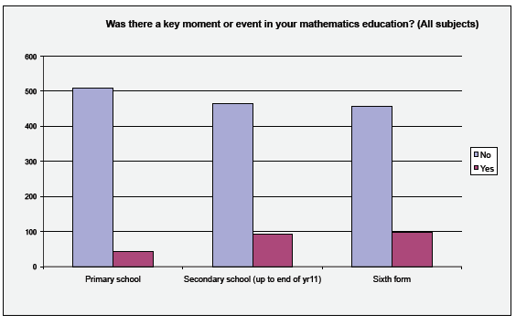

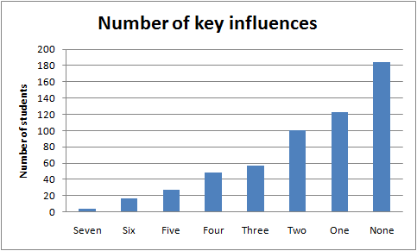

Number of Key Influences correlated with:
IA grade | IB grade | II grade | School
-0.15 | -0.06 | 0.05 | -0.06

By subject and type we see
 | % receiving no key moment | Average number of key moments
COMP | 68% | 0.41
INDEPT | 69% | 0.39
OVERSEAS | 68 % | 0.41
NS | 62% | 0.48
MATHS | 61% | 0.51
CS | 76% | 0.35
END | 78% | 0.30

Conclusion: There was no evidence of correlation between number of key moments and success. Schooling did not appear to be a factor in the number of key moments a student experiences in mathematics - 69% of respondents experience no key moment.

Appreciation of mathematics in hindsight
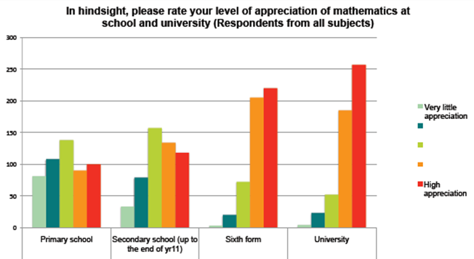

This scoring was chosen so that high grades are positively correlated with useful factors.
The grade will be that obtained in 2010 for those students filling in the survey whilst studying Part IA. For those filling in the survey whilst studying Part IB or beyond this is the grade, where available, for their Part IA. Note 2: In 185 cases tracking grades was not possible and in a few cases the Part IA grade was from a different tripos where, for example, the student had switched from Mathematics to Computer Science
In Natural Sciences Tripos the grades in Part IA are classed I, II, III.
As mentioned earlier, it seems that these were almost all chemists.
It seems that these were also almost all chemists
It seems that these were almost all experimental and theoretical physicists
Thanks to Paul Andrews from the Cambridge University Faculty of Education for this insight.
This, or course, will be based on the perception of the students
Acceleration is a positive impact; the negative sign is due to the scale used.

